Sensor signal processing

Once the sensor signals have been acquired and digitalized, the signals need to be manipulated in order to provide the desired information about momentary ambient gas concentrations on a format useful for the end user. The raw sensor output (the current through the device) in pure air (i.e. without the presence of any of the gaseous substances of interest to measure or any interfering gases, e.g. NO, NO₂, NH₃) varies to some extent between individual sensors, see Fig. 1.4.1 (a). In all cases, however, the output sensor signal can be viewed as composed of the sensor signal in pure air, often referred to as the baseline of the sensor signal while here referred to as the offset, and the part of the signal which will vary as the concentration of the gaseous substance to be measured varies. This part of the signal is commonly referred to as the response, i.e. the raw sensor signal output = offset + response. Since the offset is generally different for different sensor individuals, this offset has to be removed to be able to deduct the desired information on gaseous concentration(s) from the sensor raw data output, keeping only the sensor response vs time part of the sensor signal for further manipulation, see Fig. 1.4.1 (b).
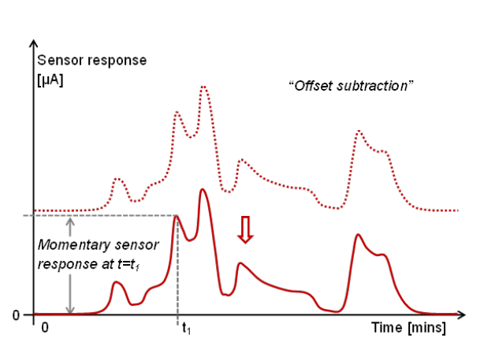
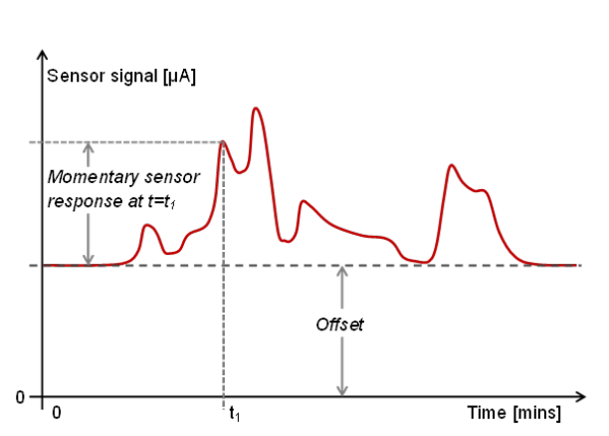

Fig.1.4.1 displays in (a) an example of a raw sensor signal output (red curve/ line) and its variation over time as the ambient gas concentration varies, in (b) the subtraction of the offset-part of the sensor signal, i.e. the signal the sensor would produce in pure air (in absence of the gas to be measured) to obtain the so-called sensor response, and in (c) the linearization of the sensor response to relate the sensor response to the ambient concentration of the monitored gas.
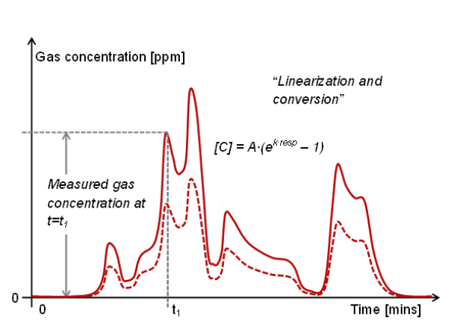

When the offset has been removed from the sensor output signal, the sensor response can for the ideal case directly be converted into a concentration value for the substance of interest to measure. As presented in Fig. 1.2.6, the general relationship between the sensor response (the gas-induced change in sensor signal) and the concentration of the substance to be measured is in almost all cases logarithmic in nature (some examples also exist of sigmoidal and other power relations between sensor signal and gas concentrations). If the sensor is exclusively selective towards the gaseous substance to be measured, the sensor response can thus be “linearized” and directly converted to values corresponding to the ambient concentration of this gaseous substance with the use of the following equation (see also Fig. 1.4.1 (c)):

[C] = A∙(e^{k∙response} – 1)

Where [C] is the concentration of the measured substance, response is the sensor response, and A and k two constants which depend on the exact interaction between the gaseous substance and the gate material of the sensor and thus need to be determined for each gas/ sensor combination (normally through some calibration procedure). The same procedure can be used also in cases when the kinds of gases, other than the one to be measured, which also can produce a change in the sensor signal are absent in the intended application of the sensor. If other substances which can affect the sensor signal are present in the ambient, additional measures may have to be taken before the information retrieved from the sensor(s) can be translated into a concentration value for the substance of interest.

Furthermore, in order to use this procedure for retrieving the gas concentration from the raw sensor signal, the sensor signal has to be stable over time. I.e. always produce the same signal when exposed to the same ambient gas composition, e.g. pure air. Otherwise the subtraction of a fix offset value will not produce a result which is consistent with the sensor response (the change in sensor signal which is solely attributed to a change in gas concentration). The signal of field effect transistor based sensors is initially exhibiting some “instability” (drift), however, also when exposed to just pure air. An example of the typical change in sensor signal following “start-up” (heating and biasing to the correct operation temperature and voltages) is provided in Fig. 1.4.2 (a). As can be seen, and as was also discussed in section 1.2, the non-gas-related change in sensor signal occurs over the first period in operation (the length of the period dependent on operation temperature, sensor material and application), after which the sensor exhibits excellent stability.

For the case of applications for which the sensor is intended to operate in a continuous mode, the situation is simply resolved by allowing for the sensor signal stabilization to occur prior to an offset “calibration” (or zero-point calibration), i.e. the establishment of the offset value under some kind of controlled/ known conditions (e.g. pure air) once the sensor signal has stabilized. For the following measurements this over time “stable” offset value is then subtracted from the raw sensor signal to generate the sensor response, from which the ambient concentration of the gaseous substance of interest can be deduced. For some cases it may also be necessary to re-run this “zero-point”-/ “offset”-calibration at regular intervals (e.g. once every six months).

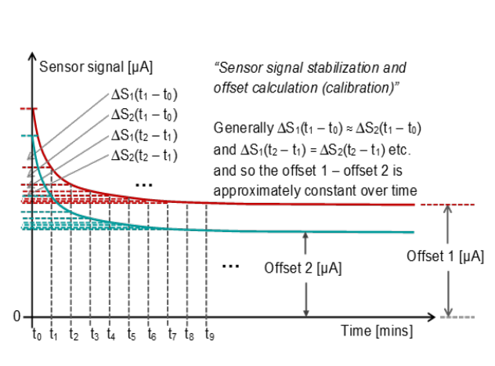
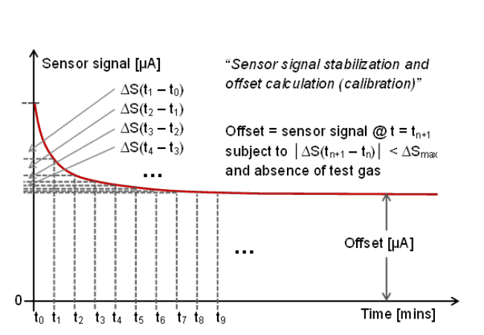

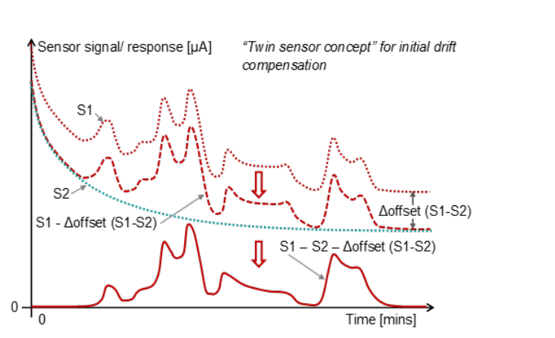
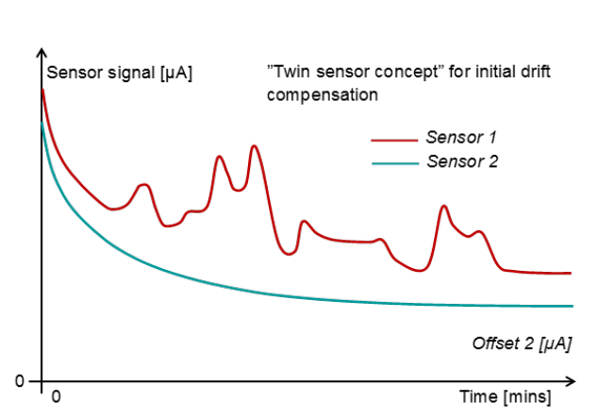

Fig.1.4.2 displays in (a) an example of the initial change in the raw sensor signal output, commonly termed drift, not related to any change in ambient gas concentration(s) and how the sensor signal stabilizes over time. In (b) through (d) the idea behind and procedure for carrying out initial drift compensation using the twin sensor concept is displayed.

As for applications where the sensor out of necessity has to be operated intermittently (e.g. for emissions monitoring in the automotive sector, where the vehicle is not running continuously year after year, and in portable, battery-operated systems) a somewhat different strategy has to be adopted to compensate for this initial drift (as in these kinds of applications it is generally of interest to be able to measure right from the beginning when the system/ process to be monitored by the sensor, and thus the sensor itself, is started up). Figs. 1.4.2 (c) and (d) provide an example of how the twin sensor concept briefly discussed in section 1.2 is used to deal with this situation. As was described in section 1.2 one of the two “identical” devices on the sensor chip, in this case identified as sensor 2 (turquoise line in the graph), is passivated, i.e. covered with a layer which will prevent substances from the ambient to interact with the gas-sensitive gate contact of that transistor. Only sensor 1 will thus respond to changes in the ambient concentration of the gaseous substance of interest to measure, see Fig. 1.4.2 (c), whereas the “sensor” 2 signal output only exhibits changes in the signal related to drift.

As both devices will exhibit more or less the same signal drift, the initial change in sensor 1 signal output not related to any changes in gas concentration can be compensated for through subtraction of the sensor signal 2 value from the sensor 1 signal value at each instant in time, basically removing the drift component from the sensor 1 signal. Since, as was also discussed earlier, even two devices on the same chip may have slightly different offsets, the difference in offset should be compensated for as well in order to obtain the true response signal of sensor 1 (Fig. 1.4.2 (d)). Once the drift-compensation has been carried out, the ambient concentration of the gaseous substance measured by the sensor can be calculated analogously to what was presented previously in this section (most commonly by experimentally determining the A and k constants and then apply the logarithmic [C] = A∙(e^{k∙response} – 1) equation to determine the concentration from the sensor response).

In many cases it is however not as straightforward to deduce the ambient concentration of one, or multiple, gaseous substance(s) as described above. Normally the ambient where the measurement is to take place comprises of a number of gaseous substances, other than the one the sensor is supposed to monitor, a majority of which are of no (or less) interest to measure but where some can still interact with the sensor (the gate contact) and to a smaller or greater extent influence the sensor signal. I.e., the sensor is in that particular ambient (environment) not perfectly selective to the gaseous substance it should measure (monitor) and so might not provide correct concentration information on the substance to be measured.

One possibility to improve the situation is the optimization of the gate material’s composition to maximize the change in gate-to-semiconductor electric field (ΔE_{gs}, or analogously ΔV_{gs}) upon interaction between this material and the substance to be measured while at the same time minimizing the change in electric field upon interaction with all the other substances present in the ambient gas mixture. Usually this equates to maximizing the interaction between the gate material and the substance of interest to measure while minimizing/ preventing the interaction with all other substances present in the particular location and for the specific intended application.

Another possibility to increase the selectivity towards the substance which should be measured (or at least increasing the accuracy of the measured value) is the following. Since the interaction of a certain substance with the gate material is different (weaker, stronger, or of a different nature) at different temperatures, and different substances may exhibit different temperature dependencies for the interactions, it is also possible to not only optimize the gate material for maximizing the interaction (or rather the change in electric field resulting from this interaction), but also the sensor operation temperature. Furthermore, since the dependence on temperature is different for different substances, additional information may be obtained, useful for the accurate monitoring of the substance of interest, if to operate the same kind of sensor at different temperatures. Consider the simple, and highly idealized (though hopefully illustrative) example provided in Fig. 1.4.3. This case assumes that the gas mixture is composed of three substances, A, B, and C, where B is the one to be measured. The sensor is sensitive to all three substances and the response of the sensor to each substance (on its own) at different temperatures is given by the relationships displayed in the graph in Fig. 1.4.3.

Furthermore it is assumed that the response of the sensor to these substances (at least within certain limits) is additive, i.e. the total response of the sensor, when operated at a certain temperature, is simply the sum of the responses each of the substances would give rise to at that temperature in the absence of the other two, i.e. the presence of the other substances does not affect the size of the response to the one to be measured, just adds the individual responses from the other two to the total change in sensor signal (the total response), which is seldom the case in reality, but for simplicity…

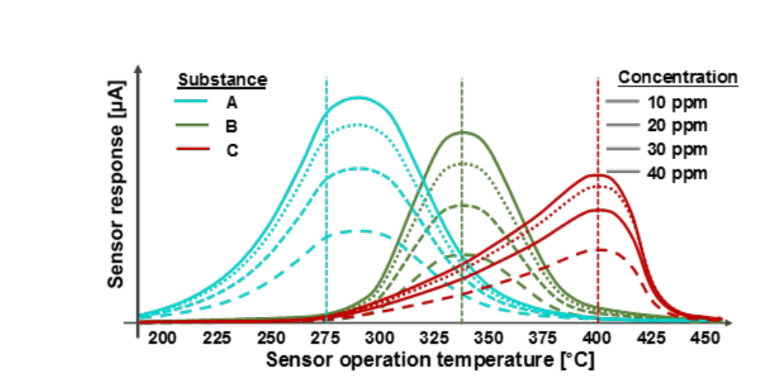
Fig.1.4.3 displays hypo-thetical response vs sensor operation temperature curves for three example substances – A, B, and C – illustrating that different substances can be measured with one and the same sensor if operated at different temperatures.

As seen from Fig. 1.4.3, at every sensor operation temperature where the sensor exhibits any response to substance B its signal (total response) is also significantly influenced by the presence of at least one of the other two substances. I.e. it is not possible to directly relate the sensor signal to the ambient concentration of substance B, at least not without knowledge of the concentrations of the other two (whereby the part of the total response related to these substances could be subtracted). The ambient concentrations of both substance A and C may, however, be directly resolved with quite good accuracy from the sensor response if the sensor is operated at temperatures of 250-275 °C (in the case of substance A, where the sensor’s response to substance B and C is more or less negligible) and 400-425 °C (in the case of substance C, where the sensor’s response to substance A and B is less significant).

Thus it follows that the concentration of all three substances could be determined with fair accuracy if to use three sensors of the same kind, but operated at three different temperatures. The A and C substance concentrations could be retrieved directly from the signals (the responses) of the sensors operated at say 265 and 410 °C, respectively, whereas the concentration of substance B could be obtained from the signal of a sensor operated at 340 °C, subtracting the sensor responses the measured concentrations of substance A and B would give rise to at that temperature from the total measured response. And then converting the remaining part of the response, the one related to substance B, to a concentration value using the normal logarithmic relationship previously discussed.

For applications where “real-time” continuous measurements are required, e.g. emissions monitoring and control of exhaust after-treatment systems in automotive applications, the arrangement with three sensor individuals is the way to go. In many cases the ambient concentration of different substances does vary only quite slowly, however, why it is not necessary to measure continuously (or even that frequently). An example of one such application is the monitoring of indoor air quality. Significant changes in the composition of indoor air (leading to bad air) occurs over minutes to hours, and the ventilation control normally also work with time constants on the order of minutes. For such cases an alternative option to the three sensor individuals could be the operation of one sensor individual in so-called temperature-cycled mode.

By temperature-cycled mode is meant the operation of one sensor at a number of different operating temperatures and in a specific sequence which is repeated over and over again. Usually the duration of the entire sequence is limited to one or a few minutes (no longer than five minutes), or even some 30-60 seconds (but due to the thermal time constants of the physical sensor chip, less than 30 seconds is normally not feasible). The total duration is naturally dependent on the number of temperatures in the sequence and the minimum possible/ recommended duration of each temperature step. As the sequence usually is limited to one or a few minutes, the number of different temperatures is usually also limited to single digits (some 3-8) and should thus be chosen wisely. An alternative element to the sequence of a number of discrete temperatures could be a temperature ramp, covering more temperatures but not allowing for steady-state (/thermodynamic equilibrium) conditions to develop and therefore, without going into detail on the basics of it, to some extent limiting the resolution of the sensor signal (the sensor response) at each momentary temperature in the ramp.

Fig. 1.4.4 (a) provides an example of a general temperature cycle with 7 discrete temperatures and a temperature ramp. As can be seen, and as was discussed in section 1.2, a change in operation temperature in itself corresponds to a change in the sensor signal. Due in part to the slight lag for reaching the set operation temperature (compare the dotted line, representing the actual sensor temperature, with the solid line, representing the set temperature, in the lower panels in Fig. 1.4.4) and in part to the time required for reaching a new equilibrium for the interactions between the sensor surface and the ambient, it is necessary to allow some time for the stabilization of the sensor signal after each step (increase/ decrease) in temperature. The sequence of temperatures over which the sensor is operated, i.e. the temperature cycle, thus gives rise to a corresponding sensor signal sequence with a certain shape in pure air (sometimes called “zero air” in the context of indoor air quality monitoring), and some slightly different overall shape in the presence of one or more gaseous substances the sensor is sensitive to, see Fig. 1.4.4 (b), in best possible case with significant differences related to the presence/ absence, and concentration, of specific substances. Fig 1.4.4 (b) provides a realistic example of such differences when a standard field effect transistor-based sensor (and using iridium as the gate material) is run in the specified temperature cycle and subjected to ammonia (NH₃), carbon monoxide (CO), and nitrogen dioxide (NO₂), each gas supplied separately.

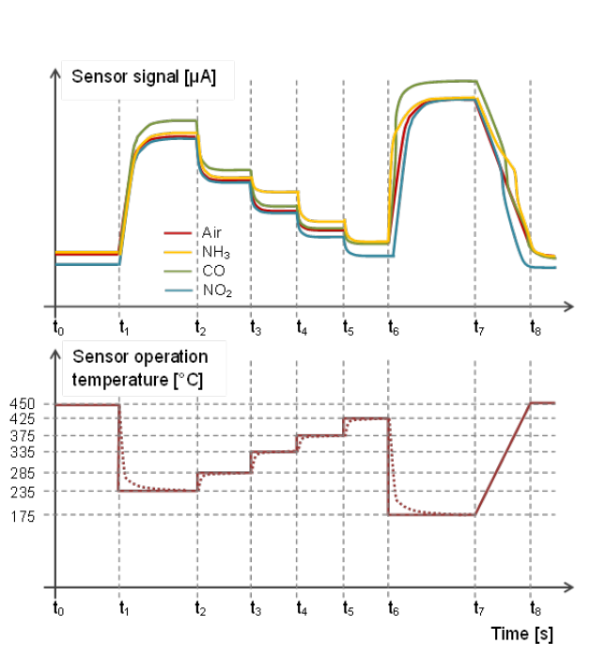
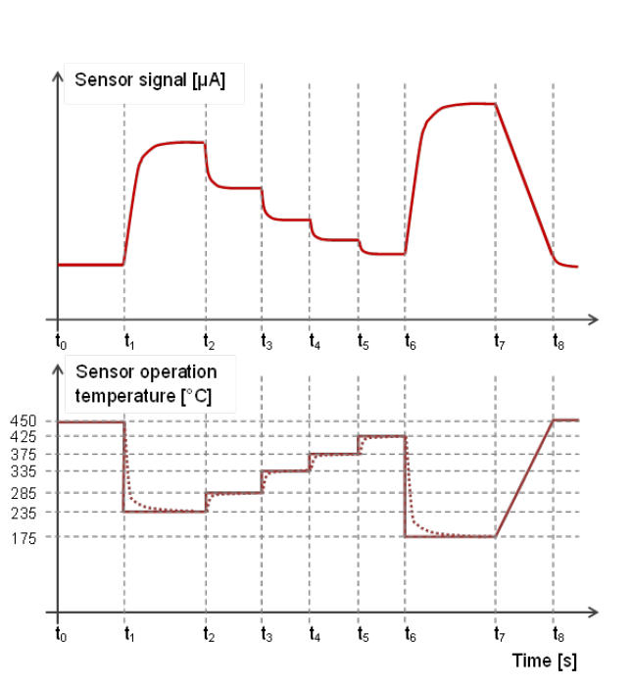

Fig.1.4.4 displays in (a) an example of a general temperature cycle (bottom) with 6 discrete temperature steps and a temperature ramp and the corresponding sensor signal (top), and in (b) the sensor signal changes introduced by different gases for different sections of the cycled sequence.

This case of NH₃, CO, and NO₂ corresponds to a somewhat less complex one, since the sensor mainly responds to CO at low operating temperatures, NH₃ at medium temperatures, and NO₂ at high operating temperatures, so in this respect resembling the simple example illustrated in Fig. 1.4.3. Approximate estimations of the CO-, NH₃-, and NO₂-concentrations, and how these change over time, could thus be obtained by calculating the responses corresponding to the sensor signal at 235, 335, and 425 °C for every cycle. It is very seldom this easy, however, also not for the case given in Fig. 1.4.3. The overlapping responses of CO and NH₃ as well as NH₃ and NO₂ are not additive. The presence of one will, in addition to producing a sensor response of its own, affect the sensor’s response to the other. This is most commonly the case and usually it is even more complex than that, with larger overlap in the response vs operation temperature curves between the different substances in the gas mixture (both the ones of interest to measure and the ones which will anyway produce a sensor response) and more substances affecting the response to one another.

One possibility for resolving the more complex cases would of course be to employ a few different sensors with different gate materials/ materials composition/ structure simultaneously, where each of them has been optimized (as far possible) for the detection/ monitoring of one specific gaseous substance out of the ones of interest to monitor in the mixture. With the aim of enhancing the response to each and every one of these while suppressing the influence of all the others on the final concentration values delivered by the sensor system (as was previously discussed).

Another possible (if maybe a little less straightforward) option is the use of even more “variables” from the same sensor (than the “variables” corresponding to the responses produced from the same sensor when operated at different temperatures, i.e. the Temp235-, Temp285-, Temp335- etc. variables). A general example for this slightly cryptically described option is provided in Fig. 1.4.5 below. Consider the same temperature cycle as in Fig. 1.4.4. The sensor signal/ response for each of the discrete temperature levels in the cycle is usually obtained by calculating the average signal over a certain period, exemplified by red diagonally striped boxes ( ) in Fig. 1.4.5, once the signal has stabilized after a stepwise change (increase/ decrease) in operation temperature. Each such average response, one per temperature level, could be viewed as a kind of variable which is assigned a (new) value (the calculated average) for each new run of the cycle.
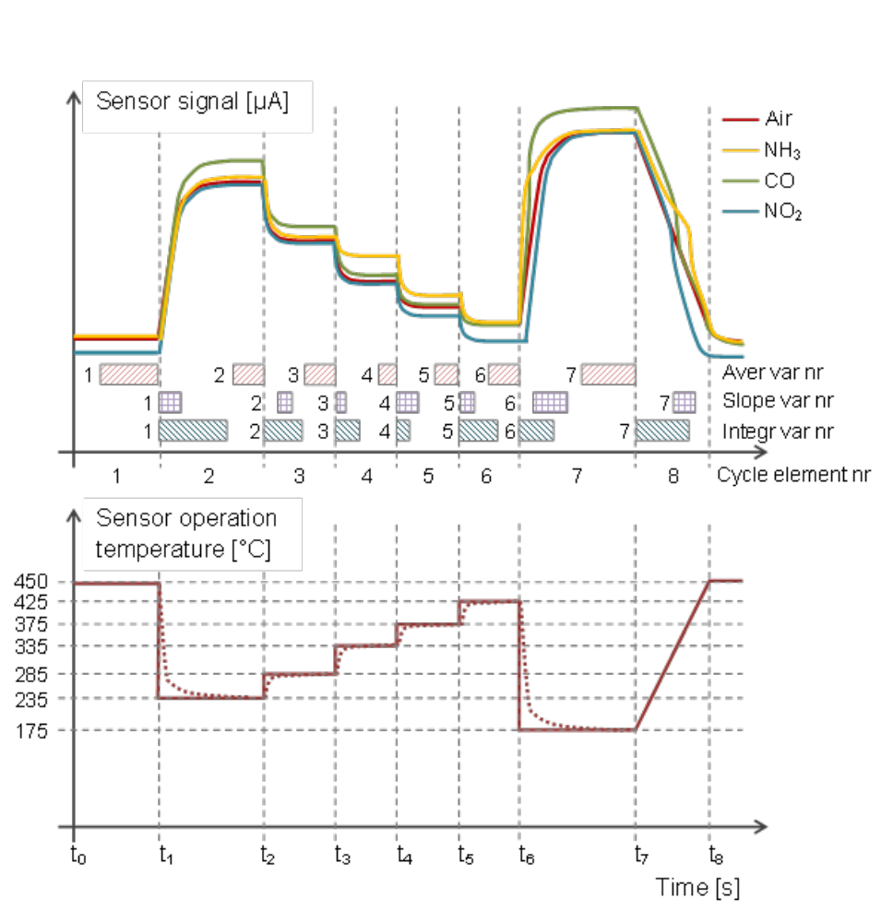

Fig.1.4.5 displays the same temperature cycle as in Fig. 1.4.4, but with examples of how new variables (so-called virtual variables) can be defined and obtained by calculating the sensor signal average, slope, or integral over different time periods in the cycle.

For the temperature-cycle displayed in Fig. 1.4.5 seven “average” variables, corresponding to the average sensor response for each temperature level in the cycle, are thus defined. It can, however, be shown that not only the average sensor response at steady-state (i.e. when the sensor signal has stabilized) and for each temperature level is able to provide specific information about the presence and concentration of different substances. Since different gases may exhibit differences in their adsorption/ desorption- or reaction kinetics upon a stepwise change in temperature, additional information may be obtained by including the transient behaviour of the sensor signal when rapidly changing from one temperature to the next.

Consider for instance that two different substances, A and B, are adsorbed to the surface of the gas-sensitive gate contact. Both of them contribute to the sensor response and the amount of each which is present on the surface is directly related to the respective ambient concentration. Since both contribute to the sensor signal, the exact amount/ concentration on the surface and in the ambient is not possible to obtain (calculate) for either of them since it is not possible to deduce individual values from the combined sensor response (10 A molecules + 90 B molecules may produce the same sensor response as 90 A molecules + 10 B molecules, or any other combination). Furthermore, assume that when increasing the temperature both of them would start to desorb more readily and the amount of each on the surface thus decrease. At a somewhat higher temperature, and after equilibrium (i.e. steady-state) has been re-established, there would thus be less of both of them on the sensor surface, and the sensor response thus smaller. Still it would not be possible to deduce individual values for the concentrations of A and B from this combined response.

If, however, there is quite some difference in how fast the molecules of A and B desorb, this could offer a possibility to obtain much more information (/estimates) about also the individual concentrations. Looking, for illustration of the concept, at the simplest case, assume that all molecules of both A and B fully desorb (leaving no molecules of either A or B on the surface) when increasing to the higher temperature. After reaching the steady-state condition the sensor response would thus be zero (if only these two substances contribute to the sensor response, of the ones present in the ambient gas mixture). Assume also, however, that desorption of A molecules occurs much faster than desorption of B molecules. Shortly after the switch to a higher operation temperature the situation on the surface could thus be that almost no A molecules are present on the surface anymore while almost no B molecules have desorbed from the surface, i.e. the sensor response at this very moment is almost only influenced by B molecules. The sensor response at this very moment could thus, without too much uncertainty, be related to the amount of B molecules which were present on the surface just prior to the increase in sensor temperature. And the rest of the steady-state response, as obtained just prior to the increase in temperature thus be related to the amount of A molecules, whereby the ambient concentrations of both the A and B substances could be calculated.

Since there are more uncertainties related with the measurement/ calculation of a sensor signal/ response based on one or very few sample points at a specific time after the switch in sensor operation temperature is initiated, what instead is commonly used is the initial derivative of the signal (i.e. the initial rate of change of the sensor signal) upon the switch in temperature. The gas-related part of this initial derivative is almost entirely dominated by the change in the presence of A molecules on the sensor surface (thus also closely related to the amount of A molecules present on the surface (and in the ambient) just prior to the temperature switch. After each such step in temperature for the temperature cycle displayed in Fig. 1.4.5, a “slope” variable can thus be defined and a (new) value of this variable calculated for each new cycle.

For the example-cycle in Fig. 1.4.5 also seven slope-variables (or “derivative”-variables if you like) have been added to the scheme, identified through violet checkered boxes ( ). Another possible kind of variable, without any closer motivation for its use or usefulness, is obtained by integrating the sensor signal/ response over some period of time, starting at the very moment when the temperature switch is initiated. Seven “integral”-type variables ( ) have thus been added to the scheme in Fig. 1.4.5. For each cycle a total of 21 values are therefore calculated from the sensor signal, corresponding to the seven “average”-, the seven “slope”- and the seven “integral”-variables, at various periods/ instances of time in the cycle. With the cycle being continuously repeated, a matrix of data will be generated over time, with the general structure as displayed in Fig. 1.4.6.

Cycle nr (Observation) | A₁ | A₂ | A₃ | … | A_{n} | S₁ | S₂ | S₃ | … | S_{n} | I₁ | I₂ | I₃ | … | I_{n}
1 |  |  |  | … |  |  |  |  | … |  |  |  |  | …
2 |  |  |  | … |  |  |  |  | … |  |  |  |  | …
3 |  |  |  | … |  |  |  |  | … |  |  |  |  | …
4 |  |  |  | … |  |  |  |  | … |  |  |  |  | …
5 |  |  |  | … |  |  |  |  | … |  |  |  |  | …
6 |  |  |  | … |  |  |  |  | … |  |  |  |  | …
7 |  |  |  | … |  |  |  |  | … |  |  |  |  | …
8 |  |  |  | … |  |  |  |  | … |  |  |  |  | …
9  … | …  … | … |  | …  … | … | … | … |  | …  … | … |  | … | … | …  …
 |  |  |  | … |  |  |  |  | … |  |  |  |  | …
k |  |  |  | … |  |  |  |  | … |  |  |  |  | …

Fig.1.4.6 displays in (a) an example of a general temperature cycle (bottom) with 6 discrete temperature steps and a temperature ramp and the corresponding sensor signal (top), and in (b) the sensor signal changes introduced by different gases for different sections of the cycled sequence.

After some calibration- and validation-procedures it is then hopefully possible to relate the combined information provided by some (or possibly, though unlikely, all) of these variables to the concentration of one or a few substances of interest to monitor. The concentration of a substance is commonly obtained from a linear combination of some of the “average”-, “slope”-, and “integral”-variables, i.e. the concentration of a specific substance at a specific point in time estimated from the weighted combination of the calculated response-values for some of the variables, as obtained from the cycle best corresponding to that specific point in time.

Analogously to the case previously discussed in connection to Fig. 1.4.2, also when operated in a dynamic mode, e.g. temperature-cycled mode, the sensor will exhibit initial signal drift (see Fig. 1.4.7 below), however, which has to be taken into account. Similar to what was earlier described for static sensor operation (e.g. operated at one, and only one, fix temperature) and continuous measurements, the situation may simply be resolved by allowing for the sensor signal stabilization to occur prior to an offset “calibration” (or zero-point calibration), i.e. the establishment of the offset value under some kind of controlled/ known conditions (e.g. pure air) once the sensor signal has stabilized. The main difference is that for the following measurements the offset to be subtracted from the sensor signal to generate the virtual sensor signals is different for different operating temperatures in the cycle and generally also different for the “average”, “slope”, and “integral” variables (virtual sensors) at a certain temperature. Thus, when performing the zero-point (offset) calibration a separate offset value has to be established for each “virtual sensor”, i.e. each defined variable at each of the corresponding temperatures, see Fig. 1.4.7 below. All these offset values are then stored and later subtracted from the virtual sensor signals during real measurements to obtain the “responses” of these virtual sensors under different ambient gas mixtures/ concentrations.

For applications such as indoor air quality monitoring, where the concentration of the gaseous substances to be measured are not expected to vary over a really wide range (usually restricted to the sub-ppm range), “linearization” of the sensor signal may not be necessary, but for the general case each of the obtained virtual-sensor responses (e.g. the response calculated for the average variable at 250 °C or the response for the slope variable at 375 °C) should be linearized, using for example a logarithmic or power relationship. Contrary to the case of static sensor operation, it is common practice to additionally “normalize” the obtained responses from the virtual sensors, however. In “normalizing” the virtual sensor responses the calculated responses are scaled by some factor, e.g. divided with the corresponding offset value, to ensure that the different virtual sensors are only evaluated based on the actual information each such “sensor” can provide when establishing the equation, i.e. the weighted linear combination of momentary virtual sensor signals, for calculating the ambient gaseous concentration of a specific gaseous substance. At a first glance this may seem a bit “cryptic”, but is actually quite straightforward.

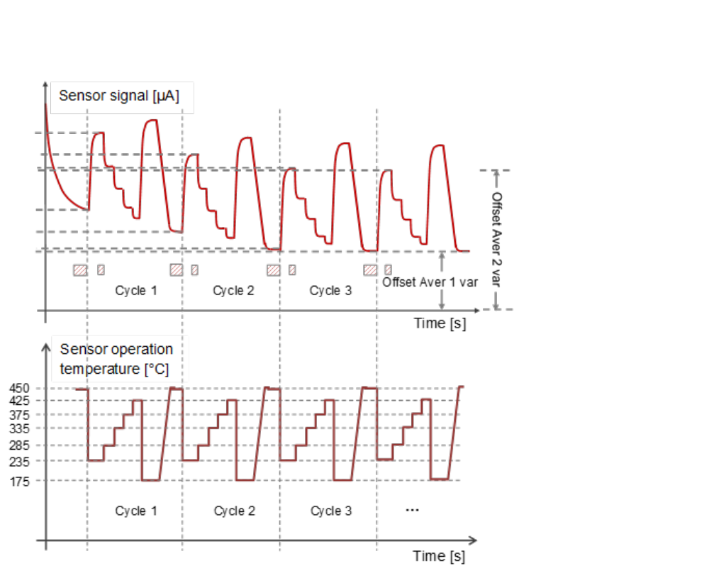

Fig.1.4.7 displays, in analogy with figure 1.4.2 in (a) an example of the initial change in the raw sensor signal output, commonly termed drift, when operating the sensor in temperature-cycled mode and how this affects the calculation of offset values for each individual virtual variable.

A sensor operated at “low” temperatures (around 200 °C) will give a significantly larger drain current signal as compared to one operated at higher temperatures, such as 400 °C (see also Fig. 1.2.4 (a)). In general, without going into detail about the underlying mechanism, also the response will be proportionally higher for exposure to some gaseous substance at low temperatures compared to the exposure for some other gas at high temperatures, even though the concentration of and the sensor’s sensitivity to both are exactly the same for the two, low and high temperature, cases. As evaluation of virtual sensor data for establishing the linear combination of virtual sensor signals in the general case is based on statistical methods, where e.g. the linear combination is established such as to maximize the co-variation between the data obtained from the linear combination of virtual sensor signals and the (measured/ supplied) concentrations of the gaseous substance to be monitored, the evaluation could be skewed to favour virtual sensor responses with a larger variation but not necessarily would provide more (or possibly even provide less) information for concentration determination. To avoid these virtual sensors to be weighted higher in the final linear model, all virtual sensor signals are therefore normalized to emphasize the information each virtual sensor can provide.

Once the virtual sensor responses have been calculated from the raw sensor signal (by calculating the average-, slope- and integral-values and subsequently subtract the offsets), linearized and normalized, and stored in a file with a structure similar to the one shown in Fig. 1.4.6, the statistics-based evaluation of this data can be performed, using a dedicated program for such statistical evaluations. This statistical evaluation will establish the linear combination of virtual sensor signals and thereby determine the weights (the factors) which should be applied to each virtual sensor for calculating the concentration of the substance to be monitored.

